

***G.H.Raisoni College Of Engineering and Management, Wagholi Pune.***

## 

**Department of Computer Engineering**

**Project Final Report**

**Submission**

**On**

**Topic: “Tourism Management “**

**Subject: Object-Oriented Programming**

**Submitted to**:

Ms. Diksha Bhoyar

**Submitted By:-Group No.: D15**

1. Ashish Thorat (SCOB129)

2. Chetana Pathak (SCOB120)

3. Samiksha Suryawanshi(SCOB121)

4.Vaishali Shinde(SCOB145)

Index

|  |  |
| --- | --- |
| SN | Contents |
| 1. | **Project Topic Description** |
| 2. | **Modules Description** |
| 3. | **Overall Source Code** |
| 4. | **Output Screen Shots** |
| 5. | **Advantages** |
| 6. | **References** |

**Project Topic Description**

The main purpose of “Tourism Management” is to provide a convenient way for a customer to book hotels, train and bus for tour purpose.

Tourism is one of the fastest growing industries today, thus within the tourism industry event are getting more and more important. People have become more interested in event of all kinds, and will travel far away to participate in event that they find interesting. Event can offer various economical and social benefits for destination and therefore destination manager and should employee event effectively in tourism role. It has become widely accepted that every community and destination needs to adapt a long term strategic approach to event tourism thereby planning and development in order to realise the full tourism potential of event. This study was launched as response to the lack of studies in how tours strategies are actually used in destination. The study was directed to tourism management system and the aim was to explore tour and travel packages. We offer tourism services include ticket booking, hotel reservation holiday tour package, domestic tour package. We provide the most suitable designed as well as the customise travel package to the customer. We offer everything related traveling service under one roof.

**Modules Description**

* After running the source code we are able to:

1. Customer.
2. Administrator.
3. Exit.

* From first page we are able to enter the Customer details which is

Stored separate for the individual customer.

* For the entries of Administrator module we create the tour, Display all the tours, customer query, Modify tour and Delete the tour.
* Option is available to select the tour, select the quantity for tour and book the tour.

**Overall Source Code**

#include<fstream>

#include<conio.h>

#include<string.h>

#include<iomanip>

#include<iostream>

#include <cstdlib>

using namespace std;

class tour1

{

public:

int tour_number;

char tour_name[50];

};

class tour : public tour1

{

float tour_price,tour_quantity,tax,tour_discount;

public:

void create_tour()

{

cout<<endl<<"Please Enter The tour Number: ";

cin>>tour_number;

cout<<endl<<"Please Enter The Name of The tour: ";

cin.ignore();

cin.getline(tour_name ,50);

cout<<endl<<"Please Enter The Price of The tour: ";

cin>>tour_price;

cout<<endl<<"Please Enter The Discount (%): ";

cin>>tour_discount;

}

void show_tour()

{

cout<<endl<<"tour #: "<<tour_number;

cout<<endl<<"tour Name: "<<tour_name;

cout<<endl<<"tour Price: "<<tour_price;

cout<<endl<<"Discount : "<<tour_discount;

}

int gettour()

{

return tour_number;

}

float gettour(float a1)

{

return tour_price;

}

char* getName()

{

return tour_name;

}

float getDiscount()

{

return tour_discount;

}

};

fstream fp;

tour t;

void save_tour()

{

fp.open("database.dat",ios::out|ios::app);

t.create_tour();

fp.write((char*)&t,sizeof(tour));

fp.close();

cout<<endl<<endl<<"The tour Has Been Sucessfully Created...";

getchar();

}

void show_all_tour()

{

system("cls");

cout<<endl<<"\t\tRECORDS.";

fp.open("database.dat",ios::in);

while(fp.read((char*)&t,sizeof(tour)))

{

t.show_tour();

getchar();

}

fp.close();

}

void display_record(int num)

{

bool found=false;

fp.open("database.dat",ios::in);

while(fp.read((char*)&t,sizeof(tour)))

{

if(t.gettour()==num)

{

system("cls");

t.show_tour();

found=true;

}

}

fp.close();

if(found == true)

cout<<"\n\nNo record found";

getchar();

}

void edit_tour()

{

int num;

bool found=false;

system("cls");

cout<<endl<<endl<<"\tPlease Enter The tour : ";

cin>>num;

fp.open("database.dat",ios::in|ios::out);

while(fp.read((char*)&t,sizeof(tour)) && found==false)

{

if(t.gettour()==num)

{

t.show_tour();

cout<<"\nPlease Enter The New Details of tour: "<<endl;

t.create_tour();

int pos=-1*sizeof(t);

fp.seekp(pos,ios::cur);

fp.write((char*)&t,sizeof(tour));

cout<<endl<<endl<<"\t Record Successfully Updated...";

found=true;

}

}

fp.close();

if(found==false)

cout<<endl<<endl<<"Record Not Found...";

getchar();

}

void delete_tour()

{

int num;

system("cls");

cout<<endl<<endl<<"Please Enter The tour #: ";

cin>>num;

fp.open("database.dat",ios::in|ios::out);

fstream fp2;

fp2.open("Temp.dat",ios::out);

fp.seekg(0,ios::beg);

while(fp.read((char*)&t,sizeof(tour)))

{

if(t.gettour()!=num)

{

fp2.write((char*)&t,sizeof(tour));

}

}

fp2.close();

fp.close();

remove("database.dat");

rename("Temp.dat","database.dat");

cout<<endl<<endl<<"\tRecord Deleted...";

getchar();

}

void tour_menu()

{

system("cls");

fp.open("database.dat",ios::in);

cout<<endl<<endl<<"\t\t tour MENU\n\n";

cout<<"P.NO.\t\tNAME\t\tPRICE\n";

while(fp.read((char*)&t,sizeof(tour)))

{

cout<<t.gettour()<<"\t\t"<<t.getName()<<"\t\t"<<t.gettour()<<endl;

}

fp.close();

}

void place_tour()

{

int order_arr[50],quan[50],c=0;

float amt,damt,total=0;

char ch='Y';

tour_menu();

cout<<"\n PLACE YOUR TOUR";

do{

cout<<"\n\nEnter The tour #: ";

cin>>order_arr[c];

cout<<"\nQuantity: ";

cin>>quan[c];

c++;

cout<<"\nDo You Want To Order Another tour ? (y/n)";

cin>>ch;

}while(ch=='y' ||ch=='Y');

cout<<"\n\nThank You...";

getchar();

system("cls");

cout<<"\n\n********************************FINAL BILL************************\n";

cout<<"\nPr No.\tPr Name\tQuantity \tPrice \tAmount \tAmount after discount\n";

for(int x=0;x<=c;x++)

{

fp.open("database.dat",ios::in);

fp.read((char*)&t,sizeof(tour));

while(!fp.eof())

{

if(t.gettour()==order_arr[x])

{

amt=t.gettour()*quan[x];

damt=amt-(amt*t.getDiscount()/100);

cout<<"\n"<<order_arr[x]<<"\t"<<t.getName()<<"\t"<<quan[x]<<"\t\t"<<t.gettour()<<"\t"<<amt<<"\t\t"<<damt;

total+=damt;

}

fp.read((char*)&t,sizeof(tour));

}

fp.close();

}

cout<<"\n\n\t\t\t\t\tTOTAL = "<<total;

getchar();

}

void admin_menu()

{

system("cls");

int option;

cout<<"\n\tPress 1 to CREATE Tour";

cout<<"\n\tPress 2 to DISPLAY ALL TOUR";

cout<<"\n\tPress 3 to QUERY ";

cout<<"\n\tPress 4 to MODIFY TOUR";

cout<<"\n\tPress 5 to DELETE TOUR";

cout<<"\n\tPress 6 to GO BACK TO MAIN MENU";

cout<<"\n\n\tOption: ";

cin>>option;

switch(option)

{

case 1: system("cls");

save_tour();

break;

case 2: show_all_tour();

break;

case 3:

int num;

system("cls");

cout<<"\n\n\tPlease Enter The tour Number: ";

cin>>num;

display_record(num);

break;

case 4: edit_tour();

break;

case 5: delete_tour();

break;

case 6: system("cls");

break;

default:admin_menu();

}

}

int main(int argc, char *argv[])

{

system("cls");

system("color 00");

int option;

for(;;)

{

cout<<"\n\t1. CUSTOMER";

cout<<"\n\t2. ADMINISTRATOR";

cout<<"\n\t3. EXIT";

cout<<"\n\tOption: ";

cin>>option;

switch(option)

{

case 1: system("cls");

place_tour();

getchar();

break;

case 2: admin_menu();

break;

case 3:

cout<<"\n\tGood Bye!";

exit(0);

default :cout<<"Invalid Input...\n";

}

}

};

**Output Screen Shots**

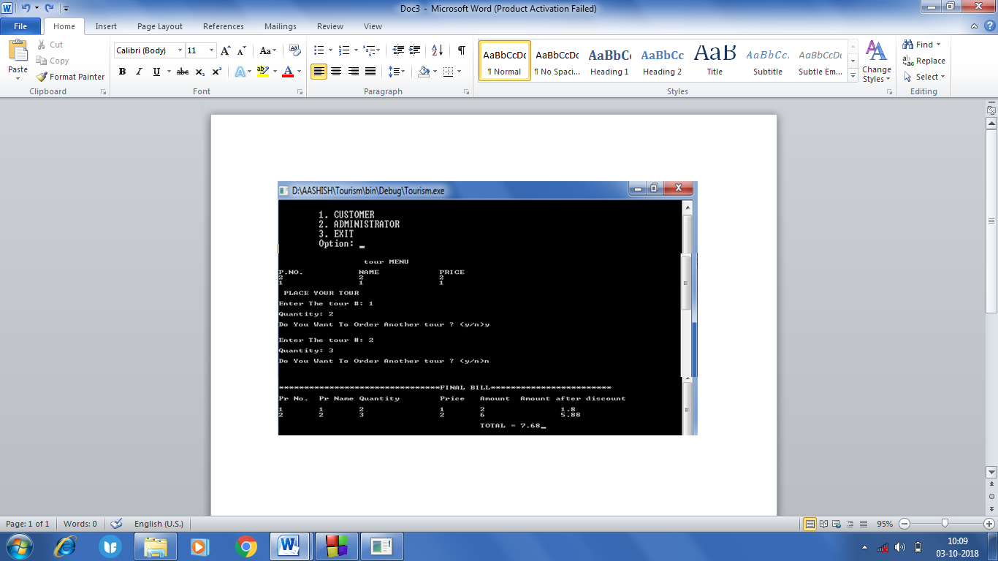

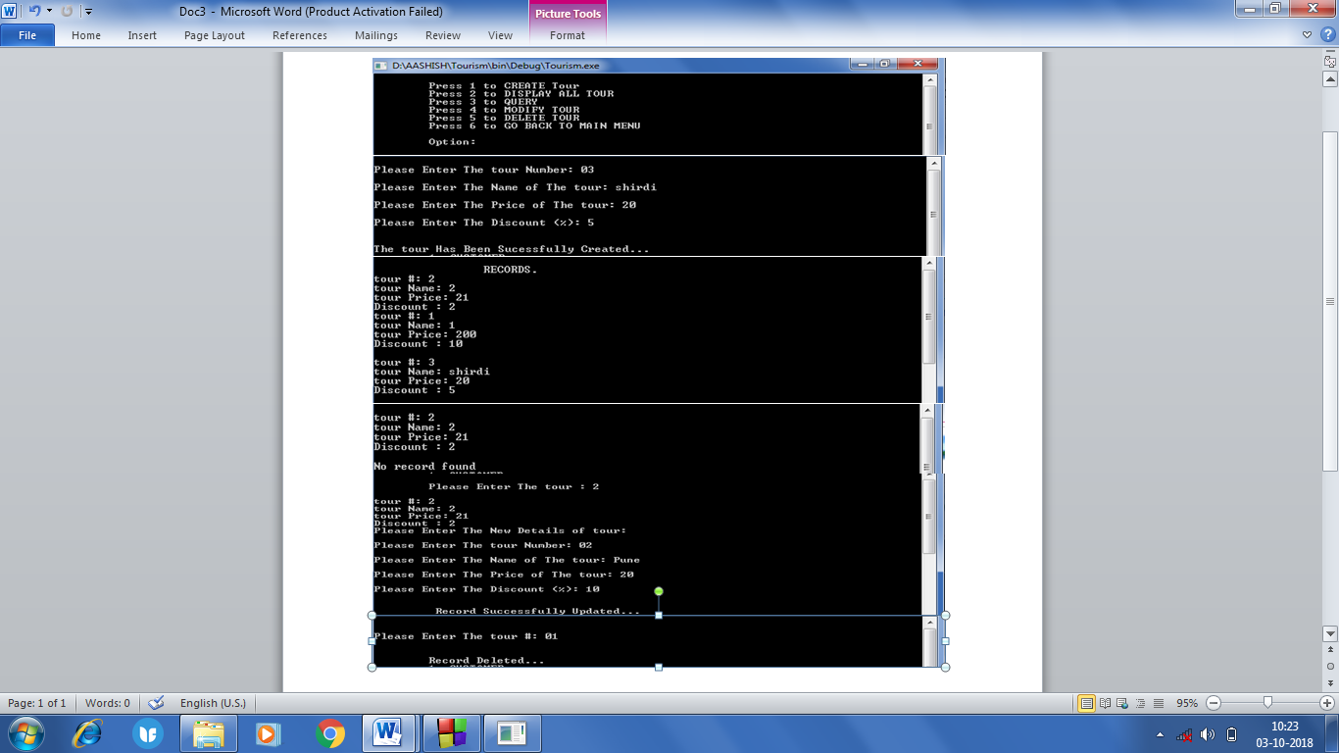

**Advantages**

* Employment is increase.
* Easy to book Tour.
* Speeding up the process.
* Easy to Connectivity of customer and Administrator.
* Secure for customer.
* It’s fairly low cost.

**References**

* [www.google.com](http://www.google.com)
* [www.wikipedia.com](http://www.wikipedia.com)
* [www.ghrcem.raisoni.net](http://www.ghrcem.raisoni.net)
* [www.tutorialspoint.com](http://www.tutorialspoint.com)